**Reverse Frogger [Single Page Design Doc]**

Game Title: Reverse Frogger  
Game platform: PC, Android  
Target Age: 1 - 12  
Rating:

Game Summary: Direct flow of traffic to prevent any frogs from crossing the road! Then reverse the roles and lead the frogs to victory.

Game Outline: Frogs are trying to cross the road again and this time, they come better prepared than before. They have trained and upgraded themselves in different combat and defence capabilities and are employing advanced strategies to cross the road tactically. We do not want to induce panic among the humans, so we have to deal with the frogs naturally, and that is using the morning rush-hour traffic on the road. By influencing the flow of traffic, we will put a stop to the frogs’ advances! We as humans must not let them cross it, or else…

Unique Selling Points:  
- A twist on the classic Frogger game  
- Plan the moves to stop the frog army advances by directing traffic, calling in vehicles, speeding up / slowing down lanes   
- Flip the switch, become the frog leader and overcome the human’s plan (your own plan!)  
- Play a variety of game modes: puzzle mode, endless mode, PvP  
- Play it turn-based, or in real-time

Map:  
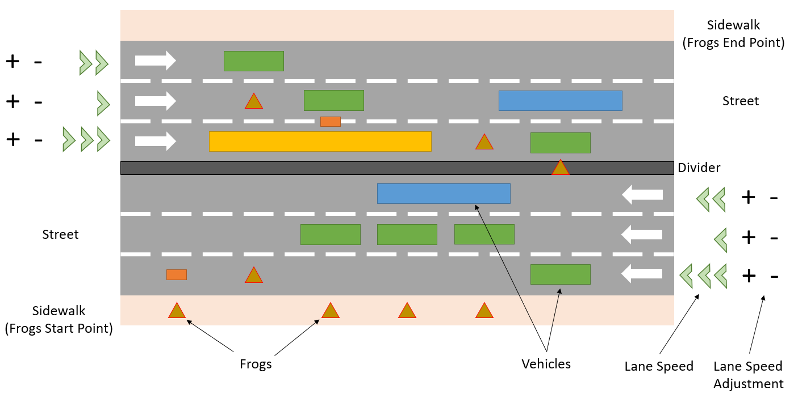

Similar Competitive Products: Frogger